Google AI Agents 5 Days Course

Day1:

A) From Prompt to Action:

Section 1:

1. Configure your Gemini API Key:
- Generate the API key in Google AI Studio
- Store this API key in the Secrets on Kaggle (will generally be stored in a env file)
- Set this key in the ‘os’ environment to using SecreteClient

2. Import ADK components:
Import the specific components you'll need from the Agent Development Kit and the Generative AI library. This keeps your code organized and ensures we have access to the necessary building blocks.
Command: pip install google-adk

Section 2:

1. Define your Agent:
- Some main properties to set:
1. name and description - give info about the Agent
2. model – what LLM model we will be using for smart generation and reasoning
3. instruction – system prompt for Agent
4. tools – tools that Agent can use to carry out specific functions
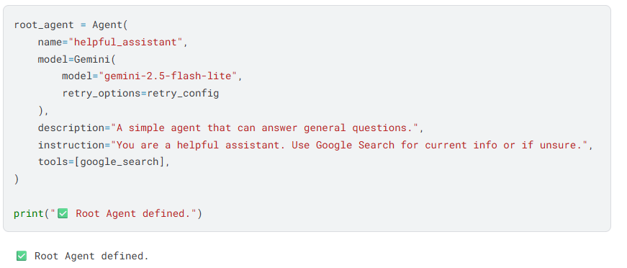

2. Run your agent:

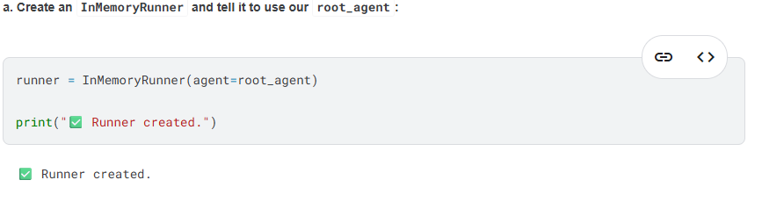

3. Call your agent:
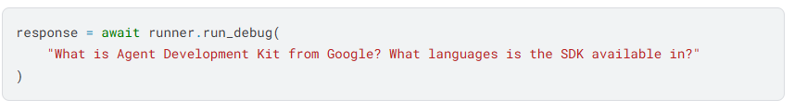

Section 3: Try the ADK Web Interface:

Commands:
1.
!adk create sample-agent --model gemini-2.5-flash-lite --api_key $GOOGLE_API_KEY

2.
url_prefix = get_adk_proxy_url()

3.
!adk web --url_prefix {url_prefix}
4. Hit following:
https://kkb-production.jupyter-proxy.kaggle.net/k/293278862/eyJhbGciOiJkaXIiLCJlbmMiOiJBMTI4Q0JDLUhTMjU2IiwidHlwIjoiSldUIn0..qsrl2rT4FzayFsZtRdfJKQ.5y0FEIU-GN1OXIHJxzpv6Xi6D4zHVdciD2G-ZPDZSBKdsQfoXhoyF4LKCSNMukhbU-2jqH-biI6hnXS6nEfTjTaewtR_B0febgBvZaNTjsCNRgr2cMYTU1DNnPP6tUBSkj9AgcCFDvfcSQN31wPWfrkDAiPoTFT9GDmacFhpkl-jpuJPGoMH9f8GswNx4DybMNekZsGYIYTKr-eWhKvgsZ_6ySvw10tU6eG65nh0rkpEL4_YWXQCBSxe1NC67yM9.-R5n07qlsSmNLl5A-_KC7A/proxy/proxy/8000/dev-ui/?app=sample_agent&session=6ec5f57f-bba2-44f9-8f36-1c6fb9fd306c&userId=user
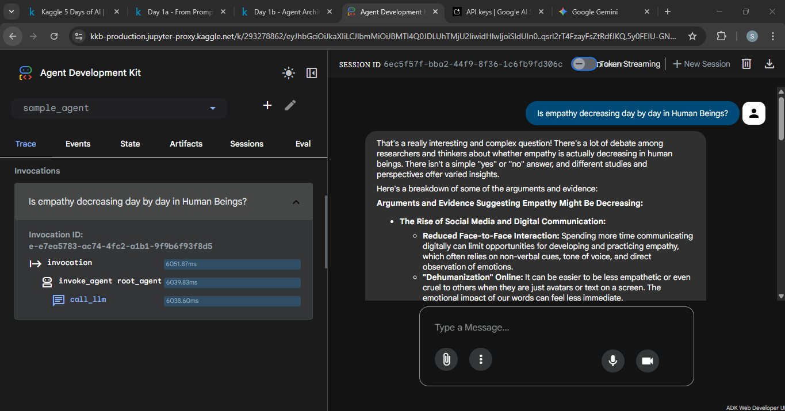

B: Agent Architectures:

Section 1: Multi-Agent Systems:
The Problem: The "Do-It-All" Agent
Single agents can do a lot. But what happens when the task gets complex? A single "monolithic" agent that tries to do research, writing, editing, and fact-checking all at once becomes a problem. Its instruction prompt gets long and confusing. It's hard to debug (which part failed?), difficult to maintain, and often produces unreliable results.
The Solution: A Team of Specialists
Instead of one "do-it-all" agent, we can build a multi-agent system. This is a team of simple, specialized agents that collaborate, just like a real-world team. Each agent has one clear job (e.g., one agent only does research, another only writes). This makes them easier to build, easier to test, and much more powerful and reliable when working together
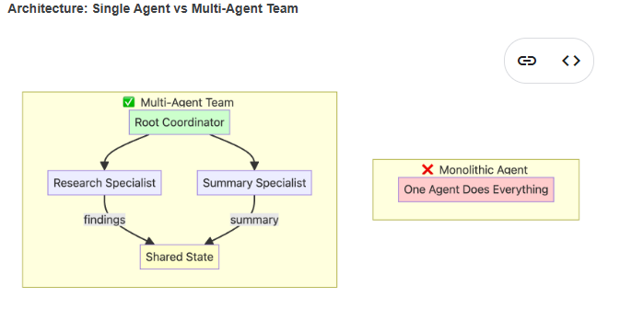
Ex:
1. Research Agent - To gather information about the user query
2. Summarize Agent – To summarize gathered information
3. Orchestrator Agent or Root Agent – Orchestrate the complete process.
Takes user query -> Call Research Agent -> Call Summarize Agent -> provide response to user

Section 2: Sequential Workflows:
When you need tasks to happen in a guaranteed, specific order, you can use a SequentialAgent (as just relying on system prompts for maintaining order is not trustworthy!)
Examples: Blog Post Creation with Sequential Agents
Let's build a system with three specialized agents:
- Outline Agent - Creates a blog outline for a given topic
- Writer Agent - Writes a blog post
- Editor Agent - Edits a blog post draft for clarity and structure
- Root Agent – To create a sequential workflow

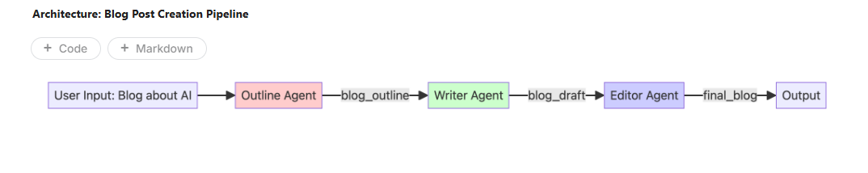
Root Agent:
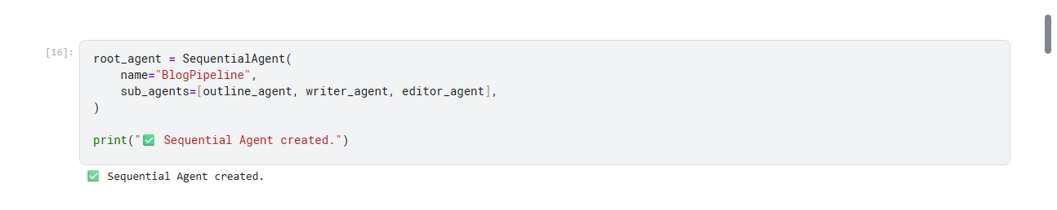

Section 3: Parallel Workflows - Independent Researchers
When you have independent tasks, you can run them all at the same time using a ParallelAgent.
Use Parallel when: Tasks are independent, speed matters, and you can execute concurrently.
Example: Parallel Multi-Topic Research¶
Let's build a system with four agents:
- Tech Researcher - Researches AI/ML news and trends
- Health Researcher - Researches recent medical news and trends
- Finance Researcher - Researches finance and fintech news and trends
- Aggregator Agent - Combines all research findings into a single summary

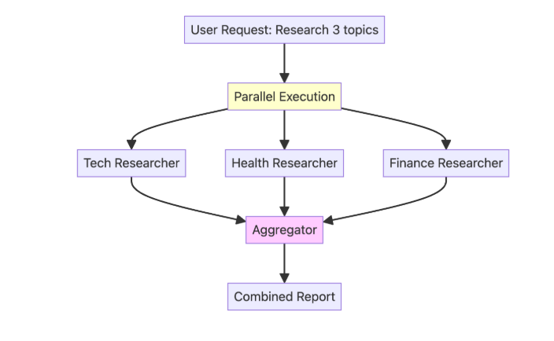

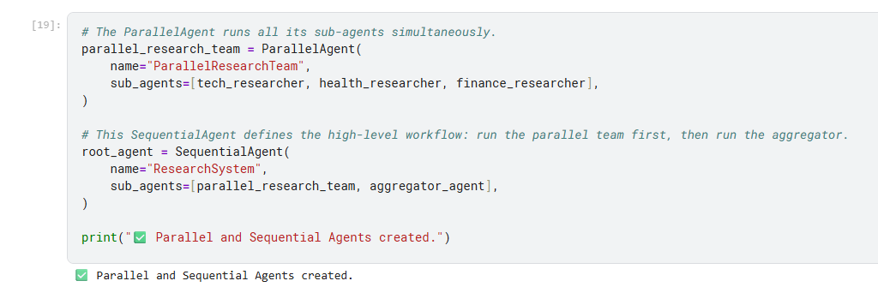

Section 5: Loop Workflows - The Refinement Cycle
When a task needs to be improved through cycles of feedback and revision, you can use a LoopAgent.
Example: Iterative Story Refinement
Let's build a system with two agents:
- Writer Agent - Writes a draft of a short story
- Critic Agent - Reviews and critiques the short story to suggest improvements

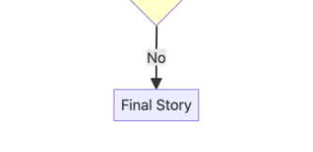
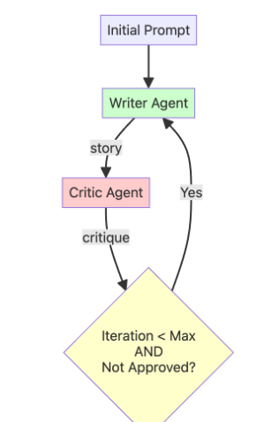

Section 6: Summary - Choosing the Right Pattern¶
Decision Tree: Which Workflow Pattern?
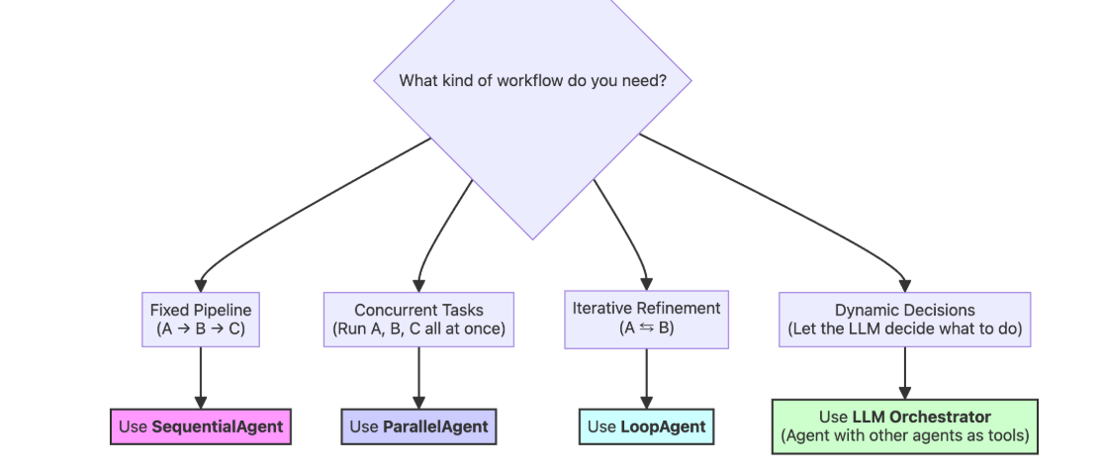
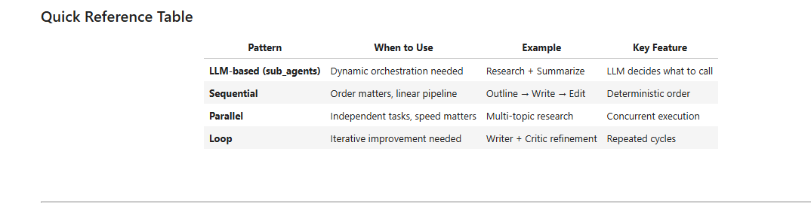
📚 Learn More
Refer to the following documentation to learn more:
- Agents in ADK
- Sequential Agents in ADK
- Parallel Agents in ADK
- Loop Agents in ADK
- Custom Agents in ADK

Day 2b - Agent Tools Best Practices

Section 1: Model Context Protocol
So far, you have learned how to create custom functions for your agents. But connecting to external systems (GitHub, databases, Slack) requires writing and maintaining API clients.
Model Context Protocol (MCP) is an open standard that lets agents use community-built integrations. Instead of writing your own integrations and API clients, just connect to an existing MCP server.
MCP enables agents to:
- Access live, external data from databases, APIs, and services without custom integration code
- Leverage community-built tools with standardized interfaces
- Scale capabilities by connecting to multiple specialized servers

How MCP Works:
MCP connects your agent (the client) to external MCP servers that provide tools:
- MCP Server: Provides specific tools (like image generation, database access)
- MCP Client: Your agent that uses those tools
- All servers work the same way - standardized interface
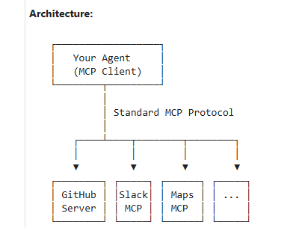

Using MCP with Your Agent
The workflow is simple:
- Choose an MCP Server and tool
- Create the MCP Toolset (configure connection)
- Add it to your agent
- Run and test the agent
1.
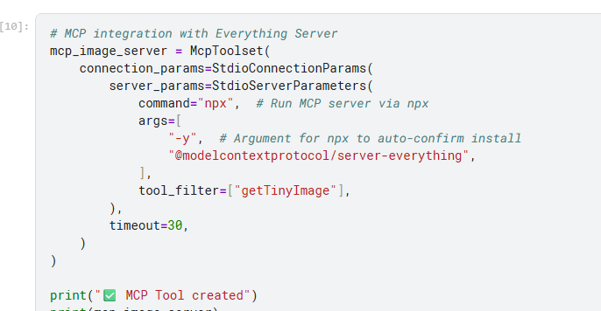

Behind the scenes:
- Server Launch: ADK runs npx -y @modelcontextprotocol/server-everything
- Handshake: Establishes stdio communication channel
- Tool Discovery: Server tells ADK: "I provide getTinyImage" functionality
- Integration: Tools appear in agent's tool list automatically
- Execution: When agent calls getTinyImage(), ADK forwards to MCP server
- Response: Server result is returned to agent seamlessly

Extending to Other MCP Servers

Kaggle MCP Server - For dataset and notebook operations:

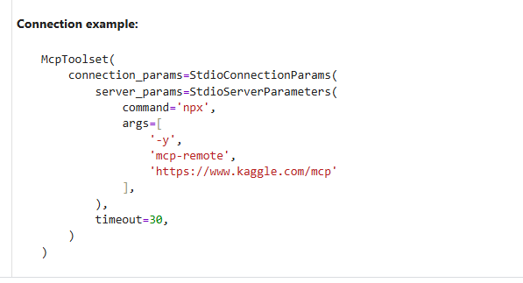

GitHub MCP Server - For PR/Issue analysis
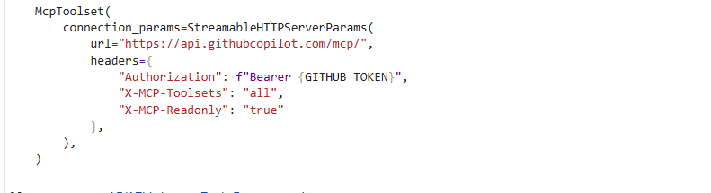

Section 2: Long-Running Operations (Human-in-the-Loop) - IMP
So far, all tools execute and return immediately:
| User asks → Agent calls tool → Tool returns result → Agent responds |
But what if your tools are long-running or you need human approval before completing an action?
Example: A shipping agent should ask for approval before placing a large order.
| User asks → Agent calls tool → Tool PAUSES and asks human → Human approves → Tool completes → Agent responds |
This is called a Long-Running Operation (LRO) - the tool needs to pause, wait for external input (human approval), then resume.
When to use Long-Running Operations:
- 💰 Financial transactions requiring approval (transfers, purchases)
- 🗑️ Bulk operations (delete 1000 records - confirm first!)
- 📋 Compliance checkpoints (regulatory approval needed)
- 💸 High-cost actions (spin up 50 servers - are you sure?)
- ⚠️ Irreversible operations (permanently delete account)

Example: shipping coordinator agent with one tool
- Auto-approves small orders (≤5 containers)
- Pauses and asks for approval on large orders (>5 containers)
- Completes or cancels based on the approval decision

The ToolContext Parameter
Notice the function signature includes tool_context: ToolContext. ADK automatically provides this object when your tool runs. It gives you two key capabilities:
- Request approval: Call tool_context.request_confirmation()
- Check approval status: Read tool_context.tool_confirmation

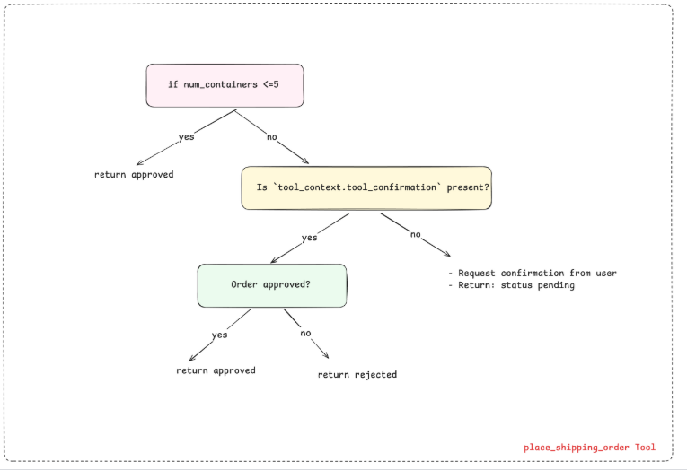

How the Three Scenarios Work (Quick Go Through….)
The tool handles three scenarios by checking tool_context.tool_confirmation:
Scenario 1: Small order (≤5 containers): Returns immediately with auto-approved status.
- tool_context.tool_confirmation is never checked
Scenario 2: Large order - FIRST CALL
- Tool detects it's a first call: if not tool_context.tool_confirmation:
- Calls request_confirmation() to request human approval
- Returns {'status': 'pending', ...} immediately
- ADK automatically creates adk_request_confirmation event
- Agent execution pauses - waiting for human decision
Scenario 3: Large order - RESUMED CALL
- Tool detects it's resuming: if not tool_context.tool_confirmation: is now False
- Checks human decision: tool_context.tool_confirmation.confirmed
- If True → Returns approved status
- If False → Returns rejected status
STEPS:
Step 1: Create the agent
Step 2: Wrap in resumable App
The problem: A regular LlmAgent is stateless - each call is independent with no memory of previous interactions. If a tool requests approval, the agent can't remember what it was doing.
The solution: Wrap your agent in an App with resumability enabled. The App adds a persistence layer that saves and restores state.
What gets saved when a tool pauses:
- All conversation messages so far
- Which tool was called (place_shipping_order)
- Tool parameters (10 containers, Rotterdam)
- Where exactly it paused (waiting for approval)
When you resume, the App loads this saved state so the agent continues exactly where it left off - as if no time passed.
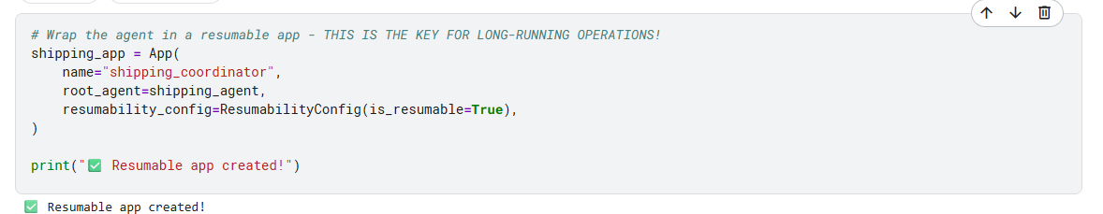

Section 3: Building the Workflow
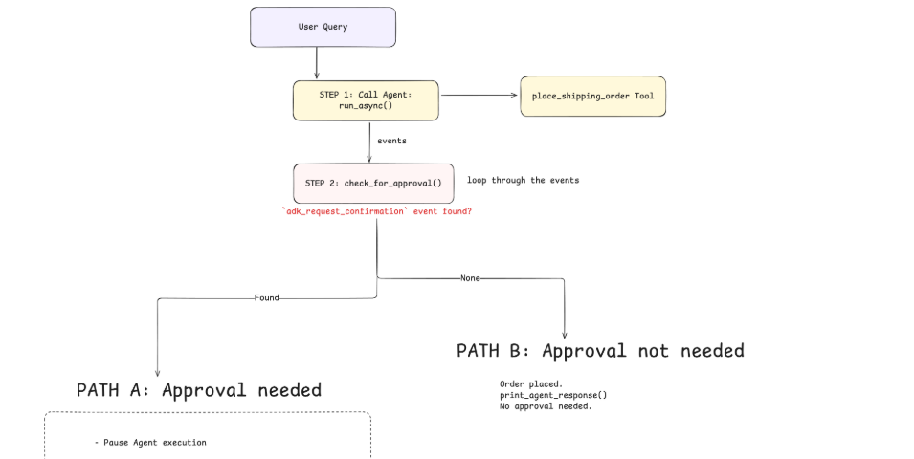
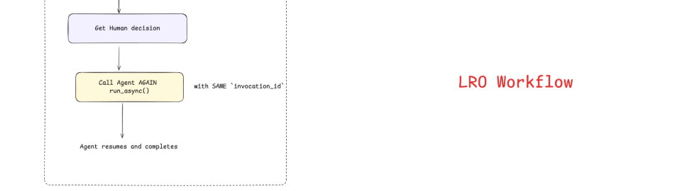
Detailed timeline:
Here's what happens step-by-step when you run run_shipping_workflow("Ship 10 containers to Rotterdam", auto_approve=True):

TIME 1: User sends "Ship 10 containers to Rotterdam"
↓
TIME 2: Workflow calls shipping_runner.run_async(...)
ADK assigns a unique invocation_id = "abc123"
↓
TIME 3: Agent receives user message, decides to use place_shipping_order tool
↓
TIME 4: ADK calls place_shipping_order(10, "Rotterdam", tool_context)
↓
TIME 5: Tool checks: num_containers (10) > 5
Tool calls tool_context.request_confirmation(...)
↓
TIME 6: Tool returns {'status': 'pending', ...}
↓
TIME 7: ADK creates adk_request_confirmation event with invocation_id="abc123"
↓
TIME 8: Workflow detects the event via check_for_approval()
Saves approval_id and invocation_id="abc123"
↓
TIME 9: Workflow gets human decision → True (approve)
↓
TIME 10: Workflow calls shipping_runner.run_async(..., invocation_id="abc123")
Passes approval decision as FunctionResponse
↓
TIME 11: ADK sees invocation_id="abc123" - knows to RESUME (instead of starting new)
Loads saved state from TIME 7
↓
TIME 12: ADK calls place_shipping_order again with same parameters
But now tool_context.tool_confirmation.confirmed = True
↓
TIME 13: Tool returns {'status': 'approved', 'order_id': 'ORD-10-HUMAN', ...}
↓
TIME 14: Agent receives result and responds to user
Key point: The invocation_id is how ADK knows to resume the paused execution instead of starting a new one.

